name: ______________________________________ date: __________________

Triangle Parallel Proportionality: Find the length of the segment listed.

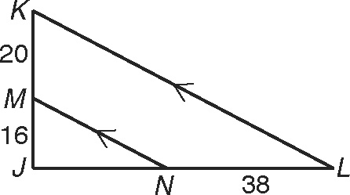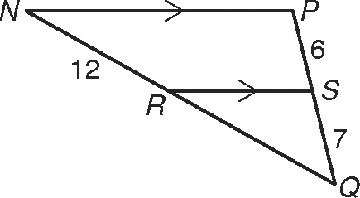 1.  2. 

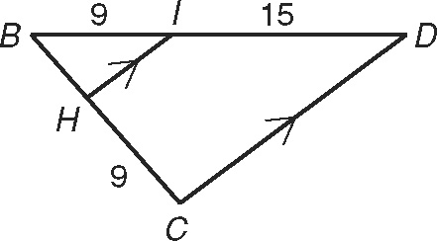 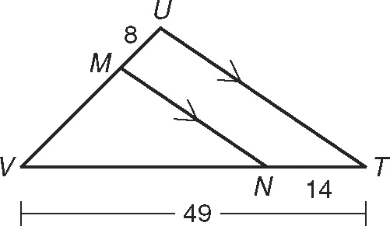

3 . BH 4. MV

**Angle Bisector Proportionality: Find the lengths of both segments listed.**

5.  and  6.  and 

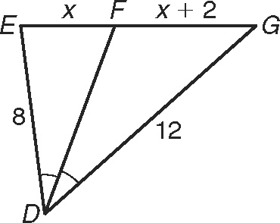 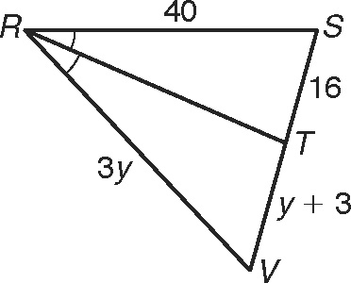

7.  and  8.  and 

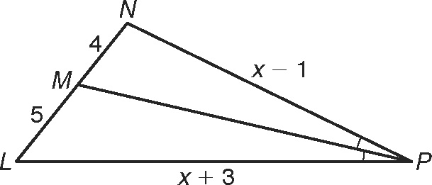 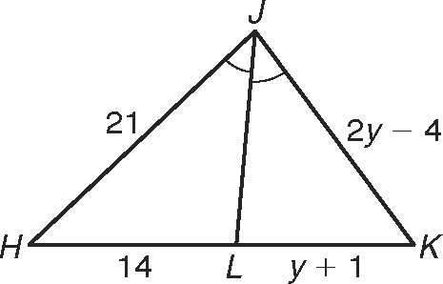

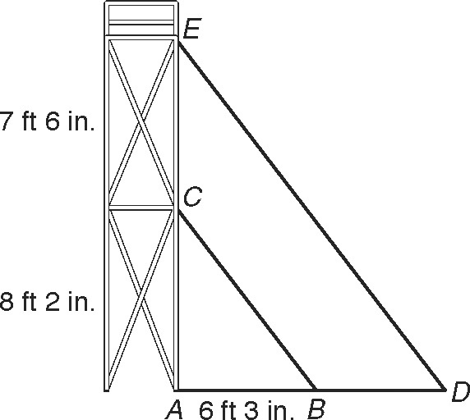

*Refer to the figure for Exercises 1–3. A city is planning an   
outdoor concert for an Independence Day celebration. To   
hold speakers and lights, a crew of technicians sets up a   
scaffold with two platforms by the stage. The first platform   
is 8 feet 2 inches off the ground. The second platform is   
7 feet 6 inches above the first platform. The shadow of the   
first platform stretches 6 feet 3 inches across the ground.*

1. Explain why ABC is similar to ADE.   
(Hint: The sun’s rays are parallel.)

2. Find the length of the shadow of the second platform in feet   
and inches to the nearest inch.

3. A 5-foot-8-inch-tall technician is standing on top of the second   
platform. Find the length of the shadow the scaffold and the   
technician cast in feet and inches to the nearest inch.

*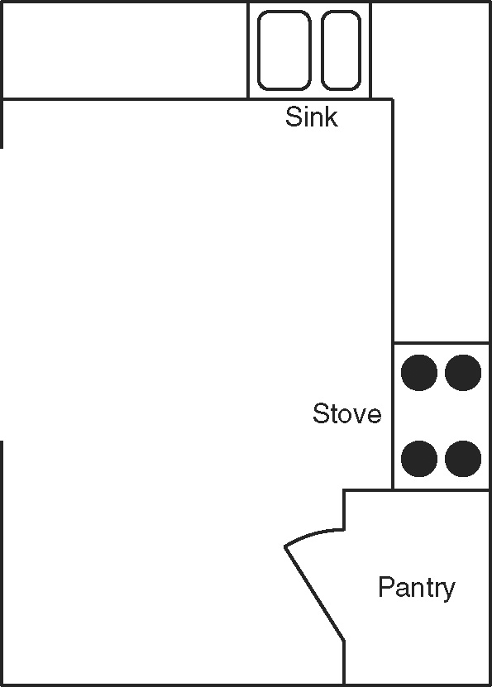Refer to the figure for Exercises 4–6. Ramona wants to   
renovate the kitchen in her house. The figure shows a   
blueprint of the new kitchen drawn to a scale of 1 cm : 2 ft.   
Use a centimeter ruler and the figure to find each actual   
measure in feet.*

4. width of the kitchen 5. length of the kitchen

6. width of the sink 7. area of the pantry

*Given that* DEFG *~* WXYZ*, find each of the following using ratios.*

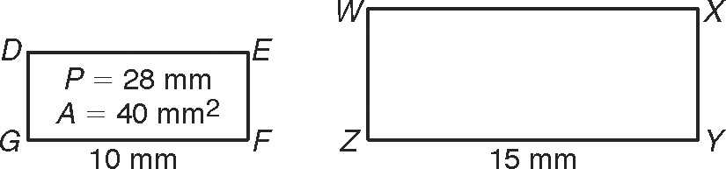

8. perimeter of WXYZ

9. area of WXYZ ______________________