Journal questions:

1. This is the geometric definition of “between” from your textbook. Explain what it means in your own words.

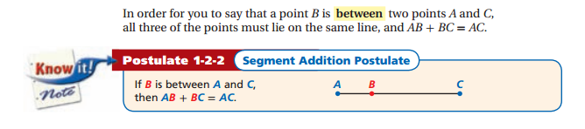

2. Consider line segment RT with midpoint S.
RS = -2x
ST = -3x-2
How long is RT?

3. What do you think the word “bisect” means in geometry?
4. ∠ABC is bisected by ray BD. If ∠ABC = 62°, what is the measure of ∠DBC?

