Advanced Tennis Corporation produces sports equipment for that sport but they are struggling to maintain market share in an increasingly competitive sector. They have decided to make their product stand out on the shelves by using unique packaging.

The marketing department wants a triangular box that can hold 4 balls, as in the illustration below. The balls fit exactly inside the box, just touching all three walls and the end caps of the container. All 3 walls of the box are the same size. Assume a tennis ball is 6 cm in diameter, and ignore the thickness of the box material.

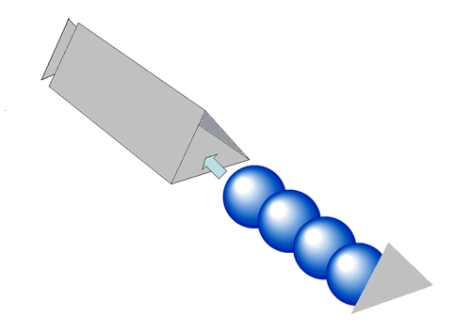
Task 1: The end of the box is in the shape of a triangle. What is the type and dimensions of the triangle to 2 decimal places?

What is the diameter of the tennis ball? ___
What is the radius of the tennis ball? ___
What is the name of the point at the center of the ball’s circular image? (point Z below) ________
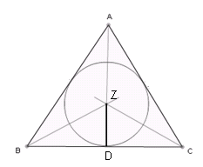
What is the measure of angle C? ______
What about the angle ZCD? _____ How do you know? ____________
What is the measure of angle ZDC? ______
What is the measure of angle DZC?______ How do you know? ____
Where is point D relative to BC? _________ Can you be sure without measuring?

(Note: Don’t worry, it’s not the deathly hallows.)

Examining the location of point D: It appears point D is in the middle of AB. But let’s be certain. The whole endcap of the package is an equilateral triangle. So each side is the same length. Let’s call that length S.

Equilateral triangle ABC. What do we know about AB and AC? ______________
Construct the angle bisector of Angle A, intersecting with BC at point D. What can we now say about angles BAD and CAD? ______ For what reason? _____________
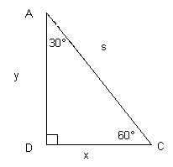
Both triangles BAD and CAD share which side? _______ So it is congruent to itself because of the ______________ property. So triangle BAD and CAD are _________ because of ______ (three letters). So BD and CD are congruence because of _______ (five letters). Since BC is S units long, BD and CD are ________ units long. So D is in fact in the middle.

Now let’s examine the triangle to the left. What is s equal to in terms of x? _____
Set up the Pythagorean Theorem for this problem.

Substitute s with what you found in the previous step. Then, solve for y.

Note the locations of x and y relative to the angle measure that are across from those sides.
Which angle measure is across from x? _____ Which angle measure is across from y? ___

Now let’s look back at Triangle ZDC from the previous page.

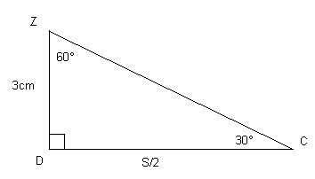
Which length do you think represents y? _____
Which length do you think represents x? _____

Now substitute and solve for the only remaining variable.

So how long is each side of the triangle? _______

Task 2: Find and calculate the surface area of the package.

Task 3: If the material to make the package costs $0.03/cm², how much will the package cost to make?

