triangle properties

Date | Concept | Homework | Due Date
10/14 T or 10/15 W | Congruence: HL and CPCTC | p. 256: 7,8, 14-17,20  p. 263: 7-11  Chapter 5 Vocab (list on p. 366, definition + picture) | 10/ 20 (Monday)
10/16 Th or 10/17 F | Isosceles and Equilateral Triangles | p. 277: 12-20; 26-29, 38 | 10/ 20 (Monday)
10/20 M | Quiz; Midsegment Theorem: Midpoint Madness task | Finish task worksheet if needed  p. 324: 11-22 | Next class
10/21 Tu or 10/22 W | Incenter and Circumcenter: construction and properties | p. 311: 12-19, 22-27 | 10/27 (Monday)
10/23 Th or 10/24 F | Medians and Centroids, Altitudes and Orthocenters | p. 318: 12-24 | 10/27 (Monday)
10/27 M | Quiz; Hinge Theorem | p. 343: 9-16 | Next class
10/28 Tu or 10/29 W | Pythagorean Triples and Inequalities, Special Right Triangles | p. 352: 9-11, 30-32, 48-51, 54  p.360: 9-16 | Next class
10/30 Th or 10/31 F | Review | Complete study guide, study for test
11/3 M | Test | none | none

skills/learning goals
1. | Extend the concept of congruent triangles to include the HL case for right triangles.
2. | Prove parts of triangles congruent using CPCTC.
3. | Recognize patterns and structures in isosceles and equilateral triangles.
4. | Prove the triangle midsegment theorem through a generalized coordinate-based argument.
5. | Construct and identify the properties of concurrent angle and perpendicular bisectors.
6. | Construct medians and their point of concurrency (the centroid); recognize the centroid as the triangle’s center of gravity.
7. | Use the ratio properties of medians and centroids to find unknown lengths within triangles.
8. | Solve inequalities of two triangles using the hinge theorem, using side-angle relationships.
9. | Recognize Pythagorean triples and understand their numerical significance.
10. | Use the patterns of 45-45-90 and 30-60-90 to instantly find missing lengths in special right triangles.

extra credit project: constructing an ancient artifact
DUE: 10/31

You are trekking in the Peruvian mountain jungles when you are approached by a Quechua local. She shows you an old artifact and asks for your help in reconstructing the geometric design on it. She says it contains special powers and may be haunted. To reconstruct it, you must:

- Construct an equilateral triangle in the center of a sheet of standard sized blank paper, with each side length of exactly 7 inches.
- Construct its three medians and its centroid, splitting the original triangle into three smaller obtuse triangles.
- Construct the incenter of each obtuse triangle, and then construct each incircle.
- Connect the three incenters to form a smaller triangle.
- Construct the circumcenter of the original, large equilateral triangle, then construct its circumcircle.

The finished product should look something like this (yours will be made by hand, not computer)

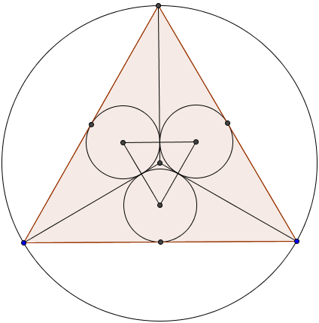

The finished product will be graded on geometric accuracy (80%) and creativity (20%). Videos to help you review compass and straight edge construction will be posted on mgeo.weebly.com

