Study Guide

Centroids and Medians

In **QRS**, **RX** **=** 48 and **QW** **=** 30. Find each length.

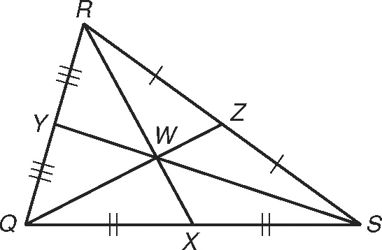 1. RW 2. WX

3. QZ 4. WZ

Orthocenter and Altitudes, using algebra

Triangle **FGH** has coordinates **F**(−3, 1), **G**(2, 6), and **H**(4, 1).

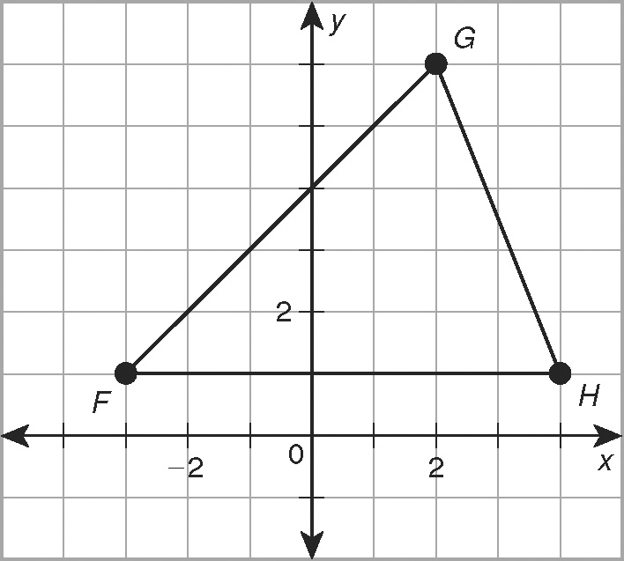 5. Draw an altitude from G to 

6. Graph the equation of a second altitude, which is

$y= -x+5$. What vertex and side does it connect?

7. Find the coordinates of the orthocenter.

Perpendicular Bisectors and Circumcenters

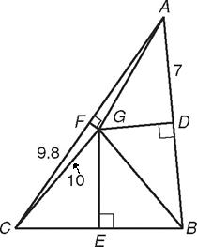Use the figure for Exercises 8-11.  and  are perpendicular bisectors of **ABC**. Find each length.

8 AG _________________ 9. DB _________________

10. AF _________________ 11. GB _________________

11b: If three friends, André 3000, Beyoncé, and Common want to

meet somewhere for lunch that’s the same distance from each of their

homes (points A, B, and C) , where should they meet?

**Angle Bisectors and Incenters**

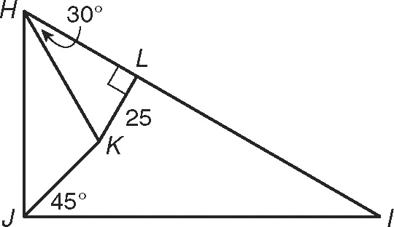Use the figure for Exercises 12-15.  and  are angle bisectors   
of **HIJ**. Find each measure.

12. the distance from K to  _________________

13. mHJK _________________

14. mJHK _________________

15. mHJI _________________

Pythagorean Theorem/Inequalities

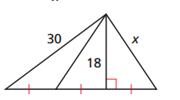Do the following lengths make a triangle? If so, classify it by its angle measure.

16. 12, 32, 31

17. 9, 40, 41

18. Find the length of x. Give your answer in simplest radical form.

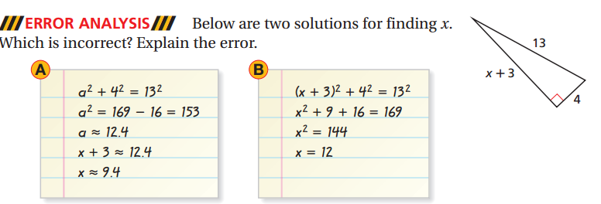

19.

**Triangle Midsegments**

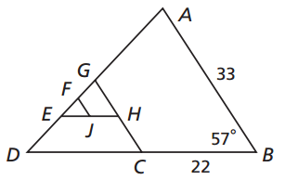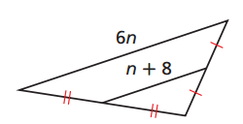20. Find the value of n. 21. GC is a midsegment. Find the length of GC and the angle measures <GCD and < GCB.

**Hinge Theorem**

22. Find a range of values for *z. 23.* **Isosceles and Equilateral Triangles**

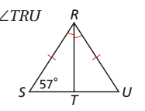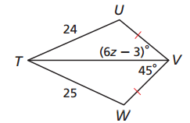

Find .

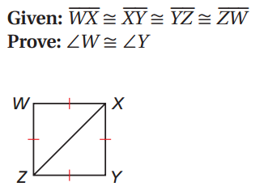

**HL shortcut and CPCTC**

24. **Given**: E is the midpoint of AD and BC. 25.

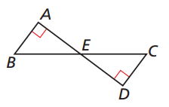**Prove**: △ABE ≅ △DCE