SSS

ASA

AAS

AAA

Other terms
to know

SAS

SSA

HL

Reflexive Property: a shared side is congruent to itself (used in proofs)
“Included” : in between
Can mark shared sides, vertical angles, and alternate interior angles of parallel lines;

Two pairs of congruent sides and the included angle

SAS guarantees congruence

Two pairs of congruent sides and a non-included angle

SSA does NOT guarantee congruence

A pair of hypotenuses and a pair of legs in 2 right triangles

HL guarantees congruence
(Right Triangles Only)

$\overline{DB}≅\overline{DB}$ by the reflexive property

CPCTC: congruent triangles have congruent parts (used in proofs)

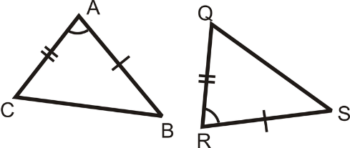

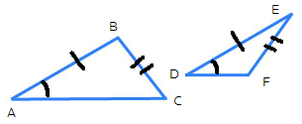

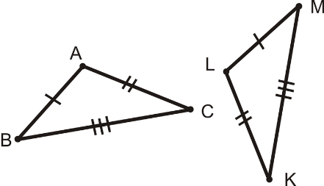

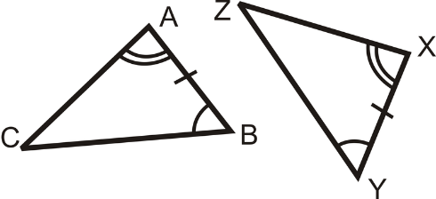

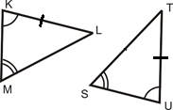

Three pairs of congruent sides in two triangles

SSS guarantees congruence

Two pairs of congruent angles and the included side

ASA guarantees congruence

Two pairs of angles and a non-included side.

AAS guarantees congruence

Three pairs of congruent angles

AAA does NOT guarantee congruence. Could be “similar”

