How to prove a quadrilateral is a parallelogram:
definition: show that opposite sides are parallel (same slopes)
1. show that both pairs of opposite sides are congruent
2. show that both pairs of opposite angles are congruent
3. show that the diagonals bisect each other (both midpoints are the same point)
4. show that one pair of opposite sides are both congruent and parallel
5. show that one angle is supplementary to both of its consecutive angles

How to prove a parallelogram is a rectangle
- Show that one angle is a 90 degrees
- Show that both diagonals are congruent

How to prove a parallelogram is a rhombus
- Show that the diagonals are perpendicular (opposite reciprocal slopes)
- Show that a diagonal bisects one pair of angles
- Show that two consecutive sides are congruent

Trapezoids
Definition: quadrilateral with exactly one pair of parallel sides

Draw a trapezoid and mark its bases and legs. Draw another trapezoid with its midsegment.
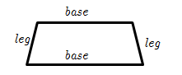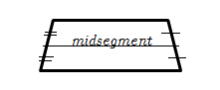
Isosceles trapezoid:
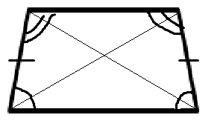
trapezoid with congruent legs. Properties:
diagonals are congruent
base angles are congruent

Kites
Geometric Definition and picture:
quadrilateral with exactly two pairs of congruent, consecutive sides
Diagonals: are perpendicular, one of them is bisected
Congruent angles: only one pair is congruent
Non-congruent angles are bisected by the diagonal.

