Area of a Regular Polygon
A $= \frac{1}{2}*apothem*perimeter$

Vocabulary:
Apothem:
Radius (for polygon):

Central Angle:

Visual Idea:
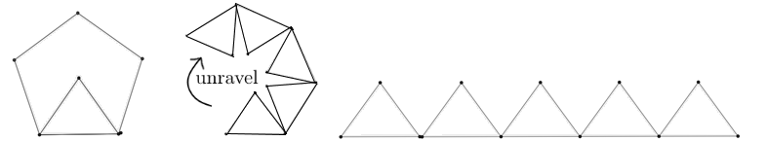

Example: How many square units fit inside the octagon?

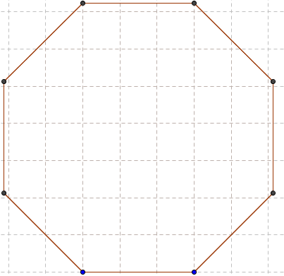

Problem 1: Apothem and Side Given
Find the area of a regular dodecagon (12s) with each side length 21.7 cm and apothem 40.6 cm. Then double the lengths and find the area of the resulting figure. How much bigger is the larger shape than the smaller?

Problem 2: Side Given
Find the area of a regular hexagon with a perimeter of 72 cm.

Problem 3: Radius given
Find the area of a regular pentagon with radius 10cm.

Problem 4: Application
The Pentagon, in Arlington, Virginia, is one of the world’s largest office buildings. It is a regular pentagon, and the length of each of its sides is 921 feet. In the center is a courtyard (also a regular pentagon) with each side 355.8 feet. What is the area of land the Pentagon building covers?
