Understanding Area Formulas

Rectangle Area: A = base * height
Draw three distinct rectangles with the same area. Then, explain how you chose your numbers.

- Parallelogram Area: A = base * height
A rectangle is a type of parallelogram, so the first formula is just a specific case of this more general formula. Turn the following parallelogram into a rectangle. Then, indicate its base and its height.

- Triangle Area: A = ½ * base * height

The height of a triangle is often not provided as part of the problem. Finding it is the central part of finding the area. In each triangle below, indicate the line representing the height of the triangle.
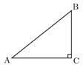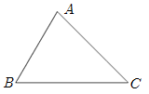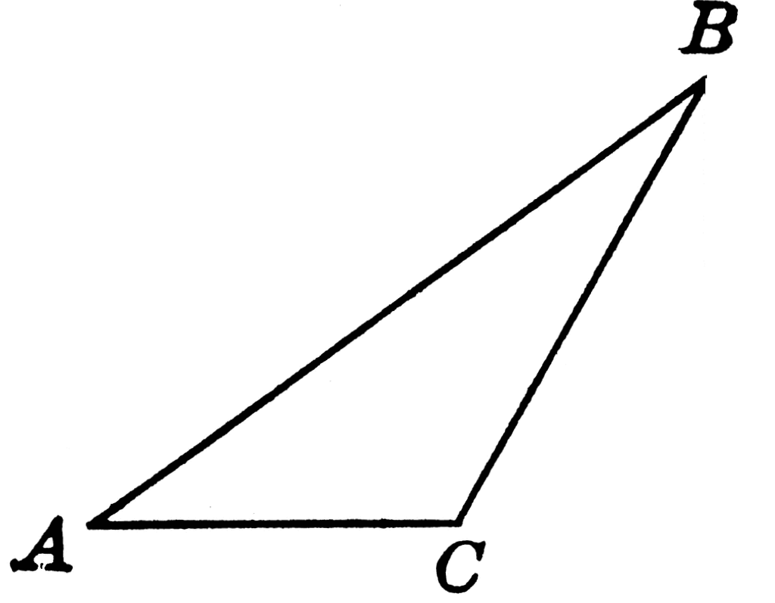

It is often said that a triangle is merely half of a rectangle, and that is why this area formula makes sense. Turn each of the figures above into a rectangle (or parallelogram).
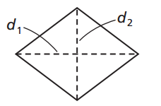
- Area of kites and rhombuses: A = ½ * diagonal * diagonal
Recall that the diagonals of any parallelogram _______________ each other. The diagonals of rhombuses and kites are special because they cross at ________________________. Use these facts to explain that the area is one half times the product of the diagonals.

- Area of a trapezoid: A = ½ * (base 1 + base 2) * height
The trapezoid differs from the previous quadrilaterals because it has two bases. Since there are two bases, each of different length, what is a reasonable way to find a value to use that is between the two?

But does that method make geometric sense? Prove that A = $\frac{1}{2}\left(b_{1}+b_{2}\right)h$ . (Hint: try to double the area, and then find half of the resulting shape’s area.)
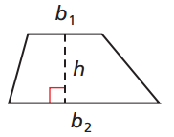

- Area of a circle: $A=π*{radius}^{2}$
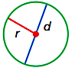
Recall from Pi-day that the ratio of a circle’s circumference to its diameter is $π$. Or, $π= \frac{C }{d}$. Solve this equation for C to find a formula for the circumference of a circle. Then, use the fact that radius r = ½ d to find another formula for circumference.

Why is the area equal to pi times the radius squared? To explain, let us subdivide the circle into pizza-like slices, then rearrange the slices as shown below.
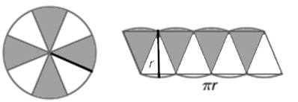
What shape does the resulting arrangement look like? What is its base and its height?

The arrangement still does not have straight lines for top and bottom, so take more slices into infinity:
What is the area formula for this kind of shape?

But since its area is the same as the circle’s area, you have area of a circle =

Practice with Area Formulas Name: ________________________________________
Solve each area problem. Indicate the correct units in your answer.

- Calculate the area of the triangle below in two different ways.

- Find the area of a parallelogram with sides 20cm and 12cm and an angle of 25º.

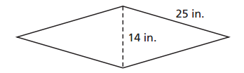
- Find the area of the rhombus:

- Find the area of the kite. (Hint: find x and y first.)
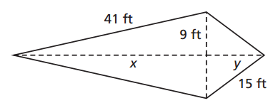

- Find the area of the isosceles trapezoid.

- Find the difference in the areas of two circles whose diameters are 10cm and 6cm. Leave your answer in terms of π.

- Two concentric circles (circles that share the same center) are shown below, where the radius of one is 5 units longer than the smaller radius. Find the differences in their cirumferences. Then, find an expression for the difference in their areas. (Hint: call the smaller radius x).
