Rectangle Area Why do the area formulas work the way they do?
1. The area of a rectangle is a very familiar formula to all students. Below, sketch a rectangle on the coordinate grid and explain why the area is equal to the base * height.
Graph for exercise 1 Graph for exercise 2
2. Draw three different rectangles which all have the same area in the space above.

Area of a triangle: why does $Area= \frac{1}{2}base*height$ always work
3. We have already explored the case of a right triangle, which is obviously half of a rectangle. But consider an arbitrary triangle ABC. Which line is the base? __________ Which line is the height? ___________________________
4. Since we don’t have height, draw a line that represents the height. Then use right triangles to explain why the area is still $\frac{1}{2}base*height$.

5. Altitudes are not always located inside the triangle. Consider another arbitrary triangle PRD, conspicuously shaped like Lion King’s Pride Rock. Is PD the height? If not, sketch a dotted line to represent the height.

6. Practice: Calculate the area of the triangle below in two different ways.
Other Quadrilateral Areas
A rectangle is a quadrilateral, but more specifically, it is a parallelogram. What is the area of a parallelogram?

7. Let’s find out. First, mark the base and the height of this shape, as b and h respectively. Can you find a way to then transform this shape into a rectangle, whose area we know how to calculate?

So parallelogram area is also A =

8. Practice: find the area of a parallelogram with sides 20 and 12 and an angle of 25 degrees.

Kites and rhombuses are also parallelograms, but their heights are not always known.
9. Recall that both of these shapes have the special property that their diagonals are _______________________. Like all parallelograms, a rhombus’ diagonals also ______________ each other. Don’t forget that a square is also a ________________.

10. Explain why the Area of a rhombus or kite is given by $A=\frac{1}{2}*diagonal*diagonal$. (Hint: find the area of one of the triangles, and then double it to find the whole area.
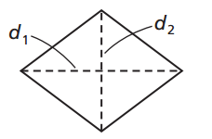

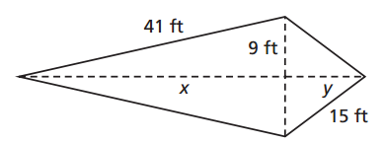
11. Practice: Find the areas of the rhombus and the kite below. (Hint: use the Pythagorean Theorem.)
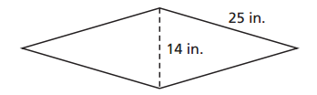

Trapezoids
The final type of quadrilateral we will investigate is the trapezoid. These are peculiar because they have two bases.
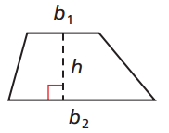
(Note that the height is, in this case, neither of the two sides.)

There are two ways to consider the reasoning behind the area
formula for a trapezoid.

12. Both rectangles and parallelograms have area base * height.
But since there are two bases here, what can we do to find an
appropriate value for the height in between both lengths?

13. Another way to consider the area is to realize that any trapezoid can be “turned into” a bigger parallelogram:

14. Practice: Find the area of isosceles trapezoid ABCD.

Circles!
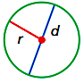
Recall from Pi Day that $π$ is the ratio of a circle’s circumference to its diameter, or

$$π=C/d$$

15. Solve this equation for C, the circumference. Then, using the fact that radius $r=\frac{1}{2}d$, find another equation for the circumference of a circle in terms of r instead of d.

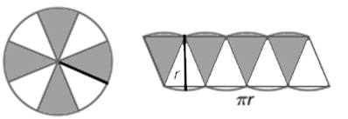
16. Hopefully you already know the area formula for a circle, but you may not know why it is A = _______________.

17. Let us subdivide a circle into a bunch of pizza-type slices, and then rearrange those slices as shown below. What shape does the resulting arrangement resemble?

What is the “height” of this shape?

What is the “base” of this shape? Why?

18. Of course, the arrangement above is not exactly a parallelogram. But the more slices you take, the closer the approximation becomes. Infinitely many slices will lead to an exact parallelogram, since the round sides straighten.

So the shape becomes a parallelogram, whose area is given by A = base * height.

Therefore the area of a circle = ( ) * ( ) ,

or, _____________________.

19. Practice: Find the difference in the areas of two circles whose diameters are 10cm and 6cm. Leave your answer in terms of $π$.

20. Two concentric circles (circles that share the same center) are shown below, where the radius of one is 5 units longer than the smaller radius. Find the differences in their cirumferences. Then, find an expression for the difference in their areas. (Hint: call the smaller radius x).

