Area of a Parallelogram

How to find height:

Area of a Regular Polygon

How to find apothem:

Area of Composite Figures

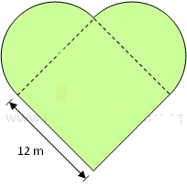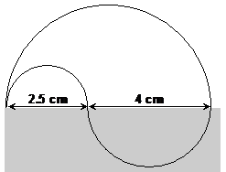

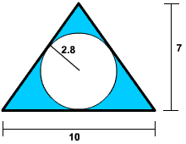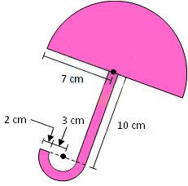

Area of a Rectangle

What happens to the area when you increase the dimensions by n times?

Area of Rhombuses and Kites

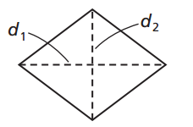

How to find other diagonal length:

Area of a Trapezoid

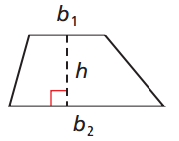

How to find height:

Circumference and Area of a Circle

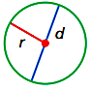
Circumference:

Area:

How to find the radius if given the diameter:

Area of a Triangle
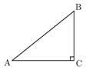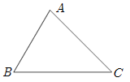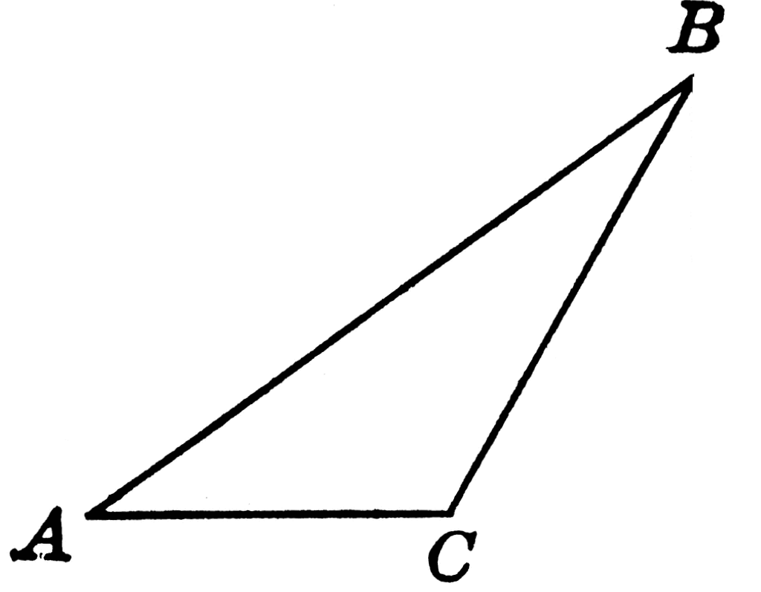

How to find height:

